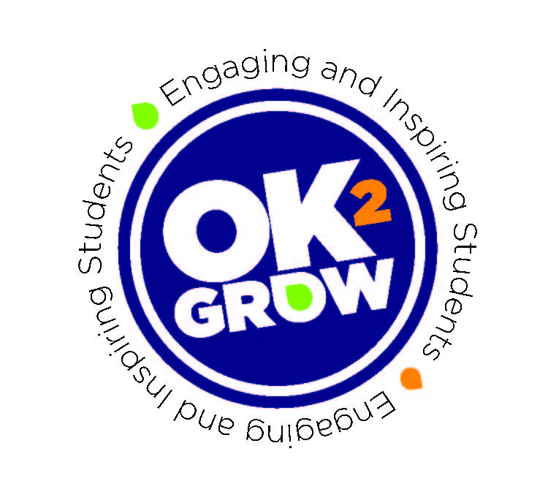
Exhibitor Event Instructions

Thank you for being a part of our Career Pathways Fair!

The students will be visiting your booth and asking questions from their “transcript.” These questions may be “what do you look for in a new hire?, what professional development or internship opportunities does your organization offer?” or related questions.
The students should turn in their transcripts to volunteers at the entrance of the fair.
When they complete their transcript and turn it in, they will be eligible for prizes like gift cards and tshirts.

