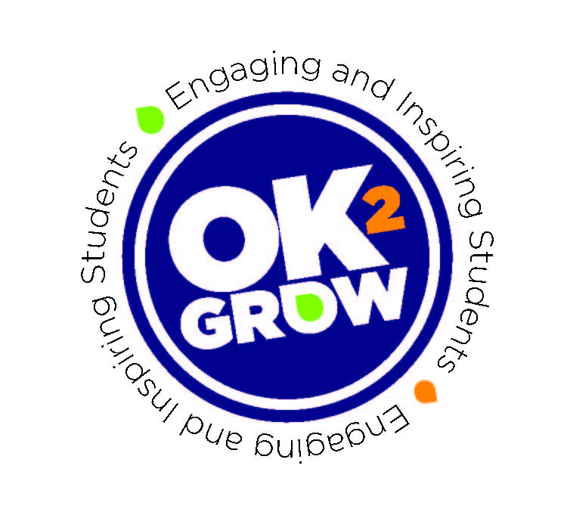

School Announcement
Friday we will be hosting a Career Pathway Fair in the cafeteria. Several business and industry partners, along with colleges and universities will be here to speak with you about opportunities available during high school and those available after high school. This fair is focusing on the importance of graduating from high school. As students enter the fair, they will receive a transcript. Students should be prepared to locate business partners at this fair and ask them questions from the transcript. Students are encouraged to visit as many booths within their allotted time and drop their completed transcript into the designated box before leaving the area. Students who complete their transcripts will have their names enter into a drawing for prizes. This is a huge opportunity for students to get information about future possibilities after high school graduation. Let’s be sure and represent our school well.

